No SQL DBs

Not only Structured Query Language

NoSQL DBs are flexible DBs, unlike SQL DBs which are tabular in nature. Since SQL is tabular in Nature it can have null values present in the columns where fields are empty that create irregularity. In such cases, we can go for NoSQL DBs like MongoDB Because in NoSQL DBs like MongoDB we put data in a JSON Object.

NoSQL is preferable when you want flexibility like in startups where things may change in the future with respect to the opportunities they get as here it’s not bound to a particular structure. But for well-established companies where operations are fixed they can go for SQL DBs in general.

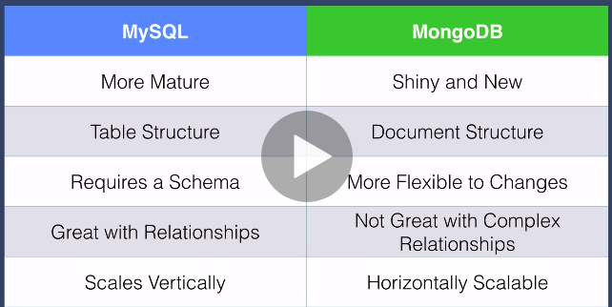

**Working with MongoDB**

MongoDB is a document-based, general-purpose, distributed database with scalability and flexibility. And most of the features are free to use.

1. **Features of MongoDB**
2. **Rich JSON Documents**

* The most natural and productive way to work with data.
* Supports arrays and nested objects as values.
* Allows for flexible and dynamic schemas.
* The document model maps to the objects in your application code, making data easy to work with.

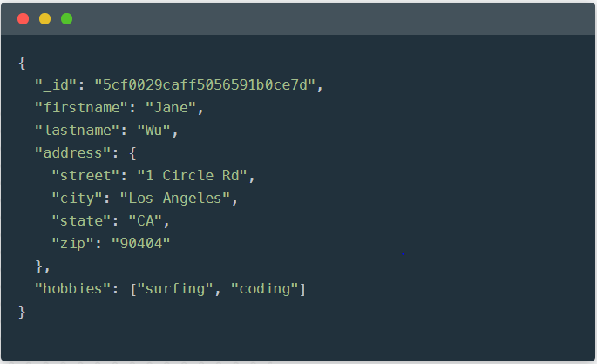

## **Powerful query language**

* Rich and expressive query language that allows you to filter and sort by any field, no matter how nested it may be within a document.
* Support for aggregations and other modern use-cases such as geo-based search, graph search, and text search.
* Queries are themselves JSON, and thus easily composable. No more concatenating strings to dynamically generate SQL queries.

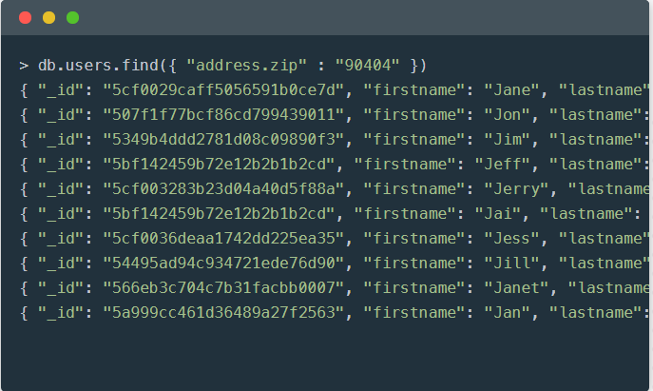

## **All the power of a relational database, and more...**

* Full ACID(Atomicity, Consistency, Isolation, Durability) transactions.
* Support for joins in queries.
* Two types of relationships instead of one: reference and embedded.

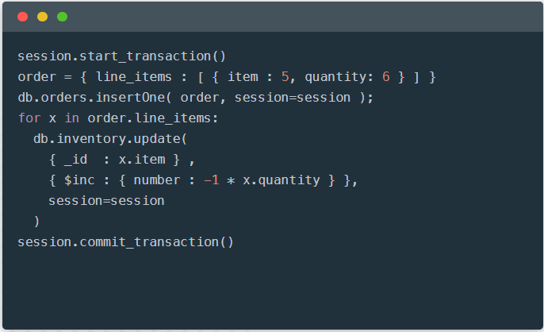

1. **Charts**

* The fastest way to create visualizations of MongoDB data.
* Built for the document model.
* Visualize live data from any of your MongoDB instances. Available on MongoDB Atlas.

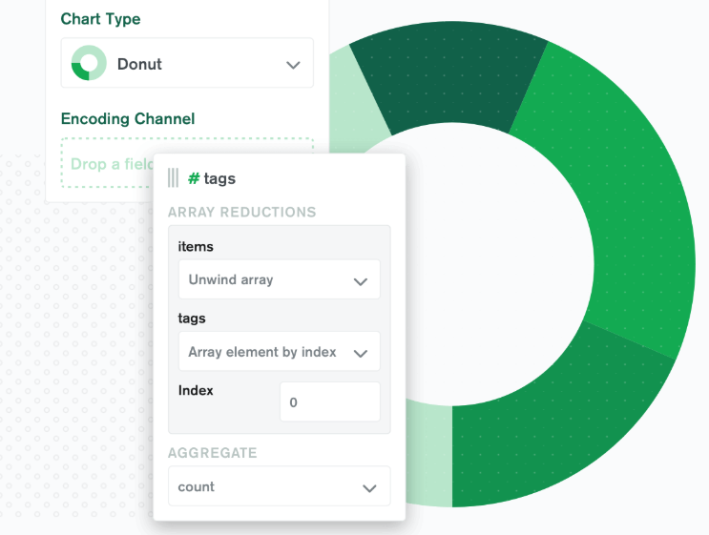

1. **BI Connector**

* Allow any BI tool that can speak the MySQL protocol to work with your MongoDB data.
* Leverage the BI tools your organization already uses.
* Perform federated analytics, combining data from MongoDB and other databases.

## **Compass**

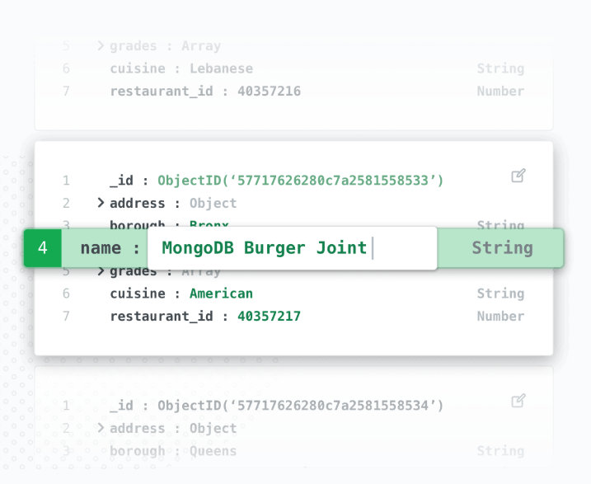

**B. Installing MongoDB**